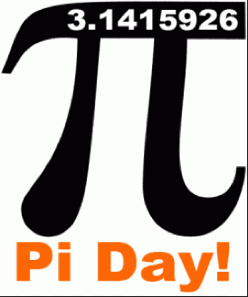

Pi Day is 3.14 -- We will celebrate Pi Day on Friday, March 10. Choose one of the following assignments. This counts as a project grade for Q3. (50 points)

Food option due Friday, March 10
Other options due Friday, March 3

- Write and perform a song with 5 facts about Pi to the tune of a nursery
rhyme or another tune. Must be typed.

- Write a creative story or poem with 5 facts about Pi. Must be typed.

- Make a decorative poster about Pi that includes 5 facts about Pi. Must be colorful, half poster size or larger.

- Make a decorative t-shirt that includes 5 facts about Pi. Must be colorful with Pi designs as well as facts.

- Make a decorative 3D Pi ornament. Must be colorful. 5 facts about Pi
must be typed and turn in with ornament.

- Memorize and say at least 40 digits of Pi. 5 facts about Pi must be typed and turned in.

- Bring any food that is round. Decorate with Pi symbol or Pi number. Calculate the area and circumference in terms of Pi … this will be done in class on Friday. 5 facts about Pi must be typed and turned in.
(Please bring plates or napkins, and forks if it is edible)

*** If you think of another creative way to illustrate Pi, let me know before
you start on it.

***If you are absent on Friday, March 10, you may NOT use the food option***

